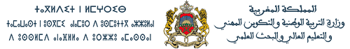
Lycée qualifiant Al araq
Contrôle numéro : 1
Semestre : 1
Durée : 1h
Nombre de pages : 3

Sciences de la vie et de la terre 1ère année bac science ex BIOF
Pr : AZAOU Mostafa Année scolaire : 2018/2019

Première partie : restitution de connaissances (5pts)
- Décrire les termes suivants :(2pts)
- Delta………………………………………………………………………………………………………………………………………………………………………………………………………………………………………………………………………………………………………………………………………………………………………………………………………………………………………………………………………………………………………………………………………
- Estuaire……………………………………………………………………………………………………………………………………………………………………………………………………………………………………………………………………………………………………………………………………………………………………………………………………………………………………………………………………………………………………………………………….

- Pour quelle raison on utilise l’eau oxygénée (H₂O₂) et l’acide chlorhydrique (HCl) avant de subir un sédiment à l’analyse morphoscopique?(3pts)
…………………………………………………………………………………………………………………………………………………………………………………………………………………………………………………………………………………………………………………………………………………………………………………………………………………………………………………………………………………………………………………………………………………………………………………………………………………………………………………………………………………………………………………………………………………………………………………………………………………………………………………………………………………………………………………………………………………………………………………………………………………………………………………………………………………………………………
……………………………………………………………………………………………………………………………………………………………………………………………………………………………………………………………………………………………………………………………………………………………………………………………………………………………………………………………………………………………………………………………………………………

Deuxième partie : exploitation des documents (15pts)
Exercice 1
L’analyse granulométrique d’un sable a donné les résultats représentés dans le tableau suivant :
Diamètre des mailles | 1,19-84 | 0,84-0,59 | 0,59-0,42 | 0,42-0,30 | 0,30-0,21 | 0,21-0,15 | 0,15-0,105 | 0,105-0,062
Refus pondérale en % | 0,2 | 0,4 | 1,2 | 25,5 | 44,3 | 17,4 | 9,3 | 1,5
- Tracer l’histogramme, la courbe de fréquence et la courbe cumulative de ce sédiment. (4pts)
- Déduire le degré d’homogénéité de ces sédiments. (1pt)
…………………………………………………………………………………………………………………………………………………………………………………………………………………………………………………………………………
……………………………………………………………………………………………………………………………………………………………………………………………………………………………………………………………………………………………………………………………………………………………………………………………………………………………………………………………………………………………………………………………………………………
- Déterminer les quartiles et déduire le degré de classement du sédiment. (3pts)
…………………………………………………………………………………………………………………………………………………………………………………………………………………………………………………………………………
………………………………………………………………………………………………………………………………………………………………………………………………………………………………………………………………………………………………………………………………………………………………………………………………………………………………………………………………………………………………………………………………………………………………………………………………………………………………………………………………………………………………………………………………………………………………………………………………………………………………
- On se basant sur votre réponse à la question 3 et sur le document X proposer une hypothèse sur le milieu et le moyen de transport de ce sédiment.(3pts)
…………………………………………………………………………………………………………………………………………………………………………………………………………………………………………………………………………
………………………………………………………………………………………………………………………………………………………………………………………………………………………………………………………………………………………………………………………………………………………………………………………………………………………………………………………………………………………………………………………………………………………………………………………………………………………………………………………………………………………………………………………………………………………………………………………………………………………………

- Une étude morphoscopique a été effectué sur les grains de quartz de ce sédiments a donné la composition suivante : NU:20% EL:10% RM:70,
- Convertir ces valeurs en histogramme circulaire. (1pt)

- Analyser ces résultats et déduire le milieu de dépôt de ce sédiment. (4pt)
………………………………………………………………………………………………………………………………………………………………………………………………………………………………………………………………………………………………………………………………………………………………………………………………………………………………………………………………………………………………………………………………………………………………………………………………………………………………………………………………………………………………………………………………………………………………………………………………………………………………………………………………………………………………………………………………………………………………………………………………………………………………………………………………………………………………………………………………………………………………………………………………………………………………………………………………………………………………………………………………………………………………………………………………………………………………………………………………………………………………………………………………………………………………………………………………………………………………………………………………

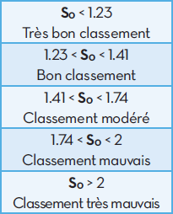
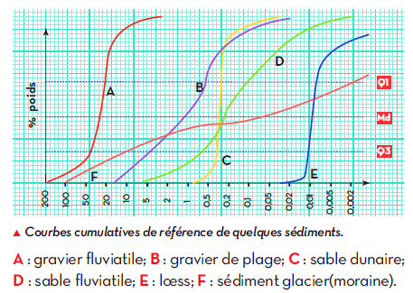

Indice de classement de Trask S₀

Document X

Bon chance

